UI Testing

# All

* We might want to have an activity title bars that indicate what activity the user is supposed to be doing… Maybe like bread crumbs, e.g., Gardening Guru: Set Zone.

# Main Activity

* We might want to change “SET ZIP CODE” to “SET ZONE”.
* We might want to change “Your hardiness zone is:” to “Your USDA hardiness zone is:” to be more descriptive.
* This text field is cut off:

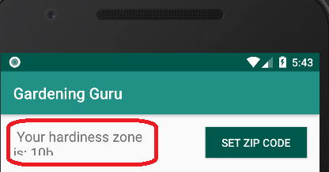

* We need a list of tasks to display in main activity. I suggest to populate it in “on resume”, and call garden.computeTasksPending before updating the list.

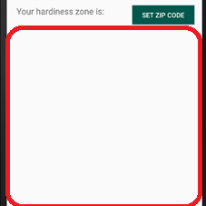

# Zone Lookup Activity

## General:

* We might want to change “SUBMIT ZIP CODE” to “LOOK-UP ZONE”. This will help the user to understand that the zone is being looked up by the zip code.

## Before looking up the zone:

* You can save the zone before any zip code is looked up. There should be an error thrown if you try to save a blank zone. Alternatively, you could just toast that the zone has been cleared.
* If you try to submit a blank zip code, nothing happens. A toast should show something like “please enter a zip code first”.

## After looking up the zone:

* The toast should be presented in a user-friendly way:

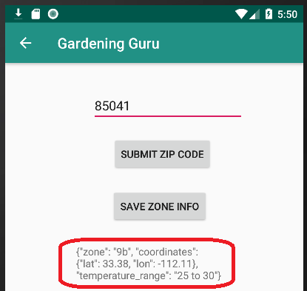

* When returning to the main activity, the zone is not displayed:

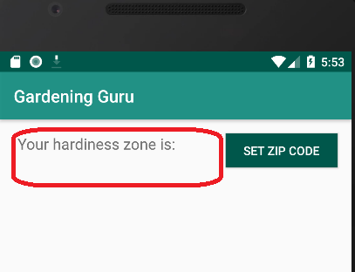

# Edit Plant Activity

## General

* Maybe the plant name should be converted to proper case automatically.

## When editing an existing plant.

* When you load a plant, you don’t know what each field indicates. This makes it hard to edit the plant. I think we need some way to indicate what each field is, other than the tip inside a blank field.

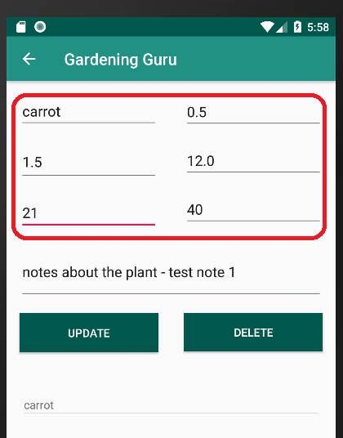

* When you have selected an existing plant, it doesn’t seem like there’s a way to clear the ui and enter a new plant. Maybe there needs to be a “NEW” button.

## When the keyboard is active:

* It seems like part of the UI is cut off by the keyboard. Maybe we can move things up a little.

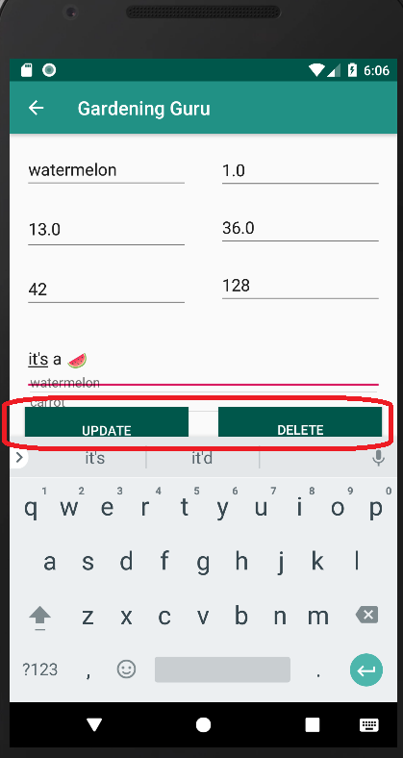

# Planting Activity

* It seems like there need to be some constraints on the planting activity UI. A lot of fields seem to overlap each other.

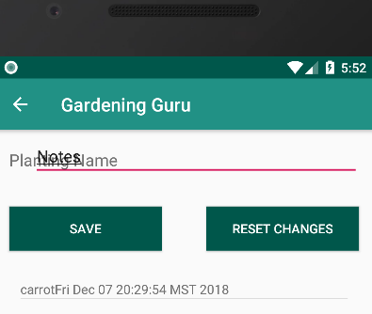

# Edit Reminders Activity

* I think we need to change the default names of tasks. The look pretty shabby:

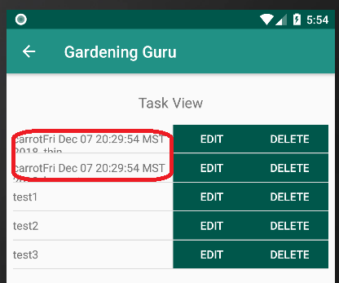

* We probably also need a max chars for task names so they don’t wrap like this, or alternatively, we truncate the displayed name in the UI.
* When we delete a task, it will probably be replaced programmatically, if it’s an autogenerated task. I think we should just mark it as done, if the user delete’s it.
* Is there a way for the user to manually add tasks? Maybe this should be a stretch goal?

# Slack notes

Ali Cope [Today at 11:35 AM]

**TO DO**

Comment UX issues here as we go through testing. If you resolve an issue, respond to it "SOLVED"

I think this will help with issues that we encounter while testing, especially if it isn't obvious what is causing the error

5 replies

Ali Cope [9 hours ago]

Formatting on task view activity, button size changes depending on tasks

Ali Cope [9 hours ago]

selecting planting causes crash

Ali Cope [9 hours ago]

planting spinner isn't functioning

Ali Cope [9 hours ago]

submit zip in Lookup Zip causes crash

Ali Cope [9 hours ago]

hardiness zone is not displaying on mainActivity